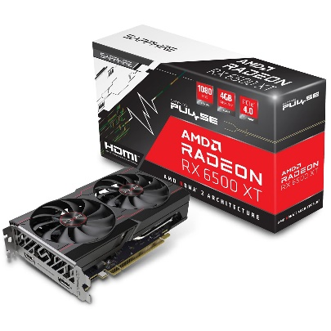

Inner

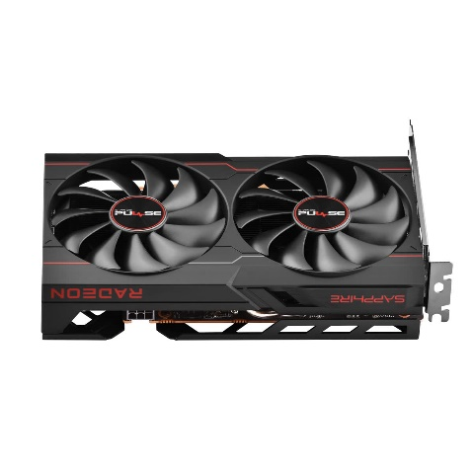

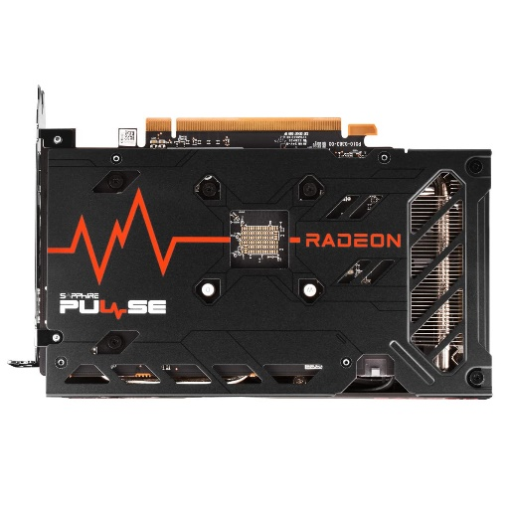

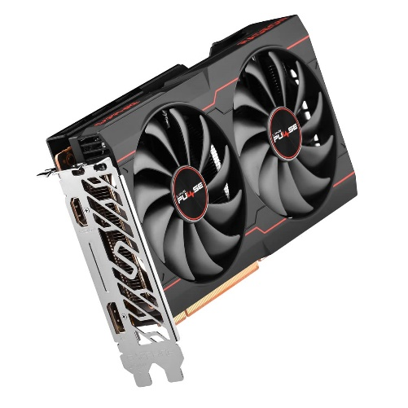

Sapphire Pulse AMD Radeon RX 6500 XT Gaming Graphics Card with 4 GB GDDR6, AMD RDNA 2, pci_e_x4

|  |  |
| --- | --- |
| M.R.P.: | ₹26,047₹26,047 |
| Deal of the Day: | ₹17,698₹17,698 |

|  |  |
| --- | --- |
| Graphics Coprocessor | NVIDIA GeForce GTX 1650 |
| Brand | Sapphire |
| Graphics RAM Size | 4 GB |
| GPU Clock Speed | 2825 MHz |
| Video Output Interface | DisplayPort, DVI, HDMI |

**About this item**

* The New Powerful GeForce GTX 1650 OC takes advantage of the cutting-edge NVIDIA Turing architecture to immerse you in incredible realism and brilliant performance in latest games
* It comes with a Display port 1. 4, HDMI 2. 0b with support for 4K (3840x2160 @ 60 Hz) and DL-DVI-D (2560x1600 @ 60 Hz). It also has HDCP support and multiple displays (Up-to 3 simultaneously)
* It comes with a single fan with 90mm ribbed, deep angled blades that increase the downward pressure ensuring better flow and has a Aluminum Sunflower Heatsink
* It supports Microsoft Direct X 12 API, Vulkan API and OpenGL 4.5. It is fully compatible with Microsoft Windows 10/7 x64. It is fully compatible with NVIDIA Ansel and compatible with NVIDIA G-SYNC
* GTX 1650 OC comes with ‘896 CUDA cores’ and operates across a 128-bit wide bus interface at speeds of 8 Gbps. It is a super compact card measuring 5.94 inch